**1.(a) Write a C Program to add two numbers.**

**CODE -**

**#include<stdio.h>**

**#include <conio.h>**

**int main()**

**{**

**int a,b,sum;**

**printf("Enter First Number ");**

**scanf("%d", &a);**

**printf("Enter Second Number ");**

**scanf("%d", &b);**

**sum = a+b;**

**printf("Sum is %d", sum);**

**return 0;**

**}**

**OUTPUT –**

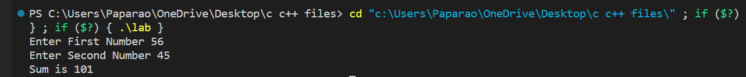

**1.(b) Write a program to add three numbers.**

**CODE –**

**#include<stdio.h>**

**#include <conio.h>**

**int main()**

**{**

**int a,b,c,sum;**

**printf("Enter First Number ");**

**scanf("%d", &a);**

**printf("Enter Second Number ");**

**scanf("%d", &b);**

**printf("Enter Third Number ");**

**scanf("%d", &c);**

**sum = a+b+c;**

**printf("Sum is %d", sum);**

**return 0;**

**}**

**OUTPUT –**

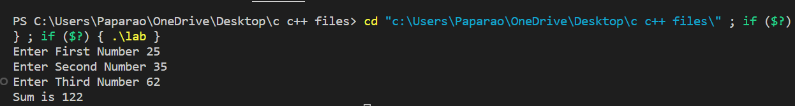

**2. (a) Write a C program to find area of circle.**

**CODE –**

**#include<stdio.h>**

**#include <conio.h>**

**int main()**

**{**

**int r;**

**float ar, pi;**

**printf("Enter Radius of Circle ");**

**scanf("%d", &r);**

**pi = 3.14;**

**ar = pi * r *r;**

**printf("The Area of the Circle is %f", ar);**

**return 0;**

**}**

**OUTPUT –**



**2. (b) Write a C program to calculate simple interest.**

**CODE –**

**#include<stdio.h>**

**#include <conio.h>**

**int main ()**

**{**

**int p,n;**

**float r, si;**

**r = 8.5;**

**printf("Enter Principal Amount ");**

**scanf("%d",&p);**

**printf("\n Enter Time Period ");**

**scanf("%d", &n);**

**printf("\n Enter Interest rate ");**

**scanf("%f", &r);**

**si = p*n*r/100;**

**printf("%f", si);**

**return 0;**

**}**

**OUTPUT –**

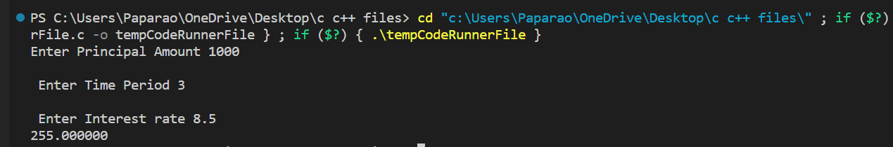

**3. Write C program to print a block F using hash (#), where the F has a height of six characters and width of five and four characters.**

**CODE -**

**#include<stdio.h>**

**#include <conio.h>**

**int main()**

**{**

**for (int i =0; i<6; i++)**

**{**

**if(i==0)**

**{**

**printf("#####\n");**

**}**

**else if (i == 2)**

**{**

**printf("####\n");**

**}**

**else**

**{**

**printf("#\n");**

**}**

**}**

**return 0;**

**}**

**OUTPUT –**

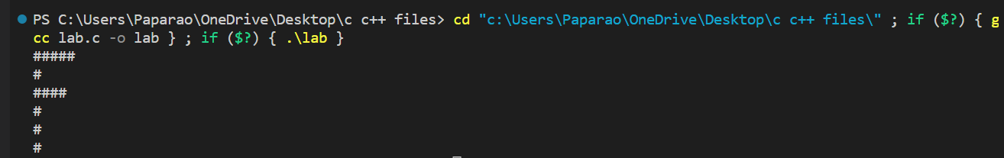

**4. Write a C program that accepts two item's weight (floating points' values) and number of purchase (floating points' values) and calculate the average value of the items.**

**CODE –**

**#include<stdio.h>**

**#include <conio.h>**

**int main()**

**{**

**float n1, n2, w1, w2, avg;**

**printf("Weight of first item ");**

**scanf ("%f", &w1);**

**printf("\nEnter number of items ");**

**scanf("%f",&n1);**

**printf("\nWeight of second item ");**

**scanf("%f", &w2);**

**printf("\nEnter number of items ");**

**scanf("%f", &n2);**

**avg = (n1*w1 + n2*w2);**

**avg = avg/(n1 + n2);**

**printf("The average weight of items is %f", avg);**

**return 0;**

**}**

**OUTPUT –**

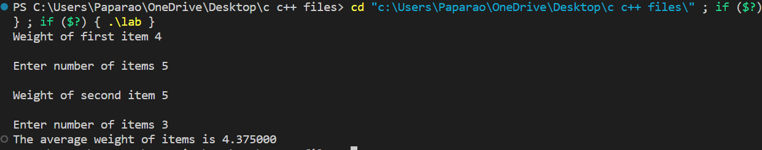

**5. (a) Write a C program to swap two variables using a third variable.**

**CODE –**

**#include <stdio.h>**

**#include <conio.h>**

**void main()**

**{**

**int a, b, c;**

**printf("Enter First Number ");**

**scanf("%d", &a);**

**printf("Enter Second Number ");**

**scanf("%d", &b);**

**c = a;**

**a = b;**

**b = c;**

**printf("First number is %d and the Second Number is %d after swap", a,b);**

**}**

**OUTPUT –**

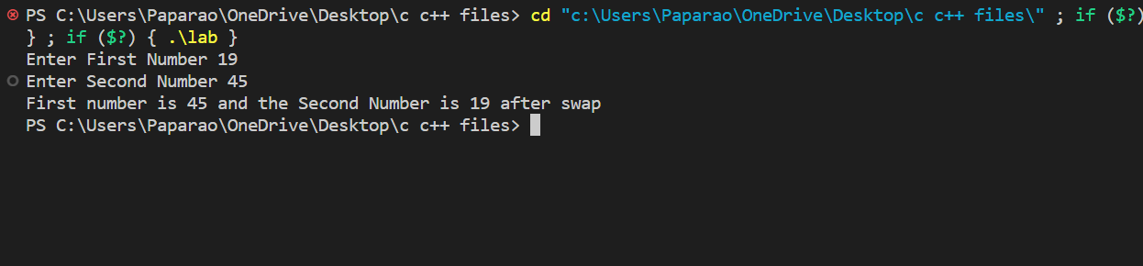

**5. (b) Write a C program to swap two variables without using a third variable.**

**CODE –**

**#include <stdio.h>**

**#include <conio.h>**

**void main()**

**{**

**int a, b, c;**

**printf("Enter First Number ");**

**scanf("%d", &a);**

**printf("Enter Second Number ");**

**scanf("%d", &b);**

**a = a + b;**

**b = a - b;**

**a = a - b;**

**printf("The First number is %d and the Second Number is %d after swap", a, b);**

**}**

**OUTPUT –**

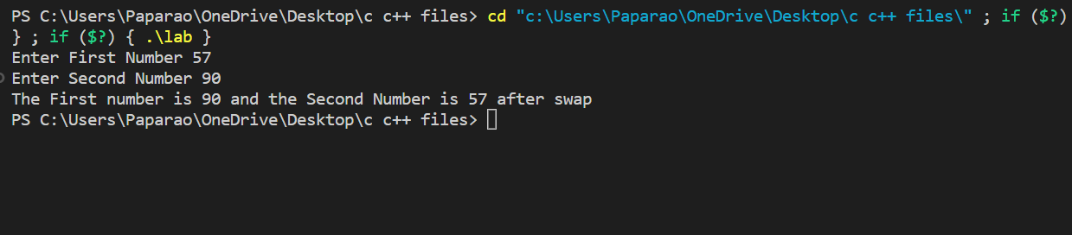

**6. (a) Write a C program to convert a given integer (in seconds) to hours, minutes, and seconds.**

**CODE –**

**#include <stdio.h>**

**#include <conio.h>**

**void main()**

**{**

**int a,seconds, minutes, hours;**

**printf("Enter Time (in seconds) ");**

**scanf("%d", &a);**

**hours = a/3600;**

**minutes = a - hours*3600;**

**minutes = minutes/60;**

**seconds = a - hours*3600 - minutes*60;**

**printf("The time is %d hours %d minutes %d seconds", hours, minutes, seconds);**

**}**

**OUTPUT –**

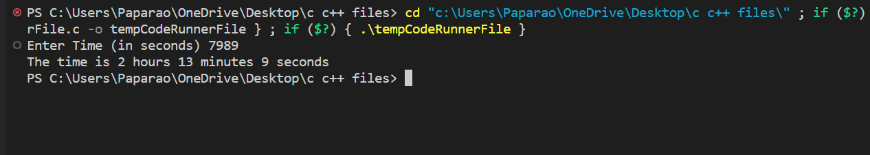

**6. (b) Write a C program to convert specified days into years, weeks, and days.**

**CODE –**

**#include <stdio.h>**

**#include <conio.h>**

**void main()**

**{**

**int a, days, weeks, years;**

**printf("Enter Number of Days ");**

**scanf("%d", &a);**

**years = a/365;**

**weeks = a - years*365;**

**weeks = weeks/7;**

**days = a - years*365 - weeks*7;**

**printf("%d years %d weeks %d days", years, weeks, days);**

**}**

**OUTPUT –**

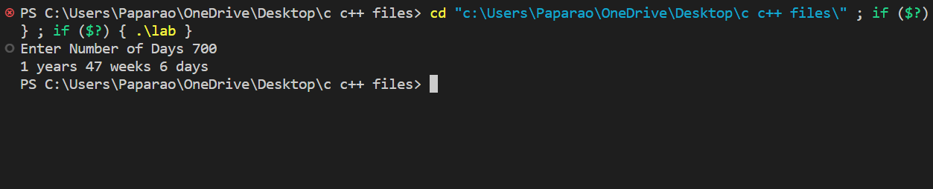

**6. (c) Write a C program to check whether a number is even or odd.**

**CODE –**

**#include <stdio.h>**

**#include <conio.h>**

**void main()**

**{**

**int a;**

**printf("Enter a Number ");**

**scanf("%d", &a);**

**if (a%2 ==0)**

**{**

**printf("Given Number is even");**

**}**

**else if (a%2 == 1)**

**{**

**printf("Given Number is odd");**

**}**

**}**

**OUTPUT –**

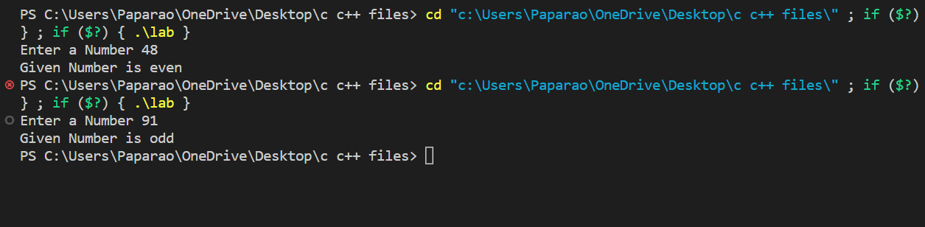

**7. Write a C program to check whether a given year is Leap year or not.**

**CODE –**

**#include <stdio.h>**

**#include <conio.h>**

**void main()**

**{**

**int year;**

**printf("Enter the Year ");**

**scanf("%d", &year);**

**if(year%4 == 0)**

**{**

**printf("The Mentioned Year is a leap year");**

**}**

**else if (year%4 != 0)**

**{**

**printf("The Mentioned Year is not a leap year");**

**}**

**}**

**OUTPUT –**

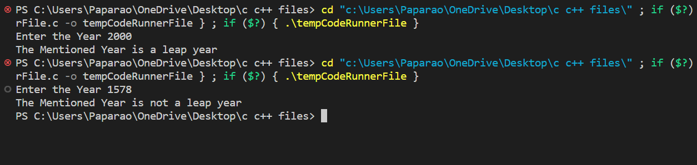

**8.(a) Write a C program to check whether a triangle is Equilateral, scalene, isosceles.**

**CODE –**

**#include<stdio.h>**

**#include<conio.h>**

**void main()**

**{**

**int a,b,c;**

**printf("Enter the first side ");**

**scanf("%d", &a);**

**printf("Enter the second side ");**

**scanf("%d", &b);**

**printf("Enter the third side ");**

**scanf("%d", &c);**

**if(a==b && b==c)**

**{**

**printf("The triangle is an equilateral triangle.");**

**}**

**else if (a==b || b==c || a==c)**

**{**

**printf("The triangle is an isosceles triangle.");**

**}**

**else**

**{**

**printf("The triangle is a scalene triangle.");}**

**}**

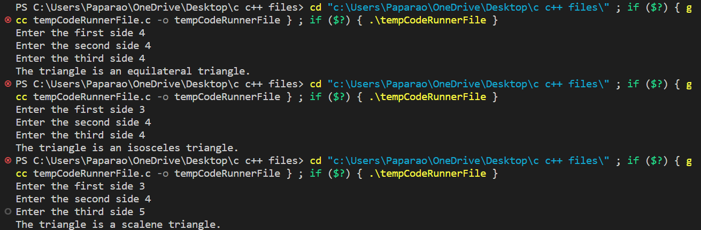

**8. (b) Write a C program to check whether a triangle is right angled, obtuse, acute triangle**

**CODE –**

**#include<stdio.h>**

**#include<conio.h>**

**void main()**

**{**

**int a,b,c;**

**printf("Enter the first angle ");**

**scanf("%d", &a);**

**printf("Enter the second angle ");**

**scanf("%d", &b);**

**printf("Enter the third angle ");**

**scanf("%d", &c);**

**if(a+b+c==180 && a!=0 && b!=0 && c!=0)**

**{**

**if(a<90 && b<90 && c<90)**

**{**

**printf("The triangle is an acute angled triangle.");**

**}**

**else if (a==90 || b==90 || c==90)**

**{**

**printf("The triangle is a right angled triangle.");**

**}**

**else**

**{**

**printf("The triangle is an obtuse triangle.");**

**}**

**}**

**else**

**{**

**printf("The given angles are not valid");**

**}**

**}**

**OUTPUT –**

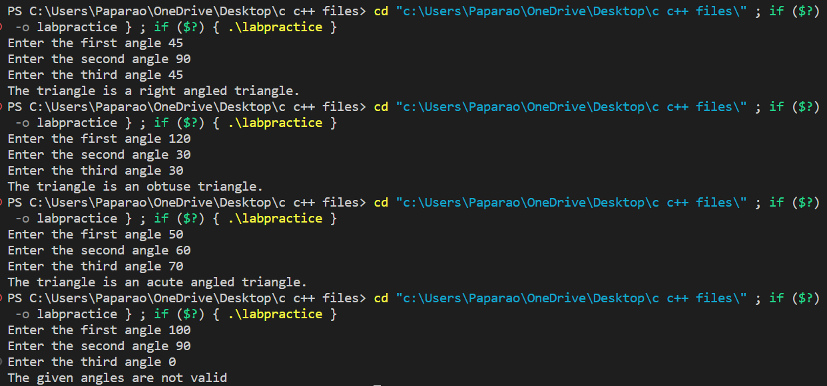

**9. Write C program to convert temperature from Celsius to Fahrenheit and Celsius to Fahrenheit (User must provide the choice of type of temperature).**

**CODE –**

**#include<stdio.h>**

**#include<conio.h>**

**void main()**

**{**

**int degree, a;**

**float cel, fah;**

**printf("Enter 1 to convert Celsius to Fahrenheit");**

**printf("\nEnter 2 to convert Fahrenheit to Celsius\n");**

**scanf("%d",&a);**

**if(a ==1)**

**{**

**printf("Enter Temperature in Celsius");**

**scanf("%d", &degree);**

**fah = 1.8*degree + 32;**

**printf("The temperature is %f in fahrenheit", fah);**

**}**

**else if (a == 2)**

**{**

**printf("Enter Temperature in Fahrenheit");**

**scanf("%d", &degree);**

**cel = 5*(degree-32);**

**cel = cel/9;**

**printf("The temperature is %f in celsius", cel);**

**}**

**else**

**{**

**printf("ERROR");**

**}**

**}**

**OUTPUT –**

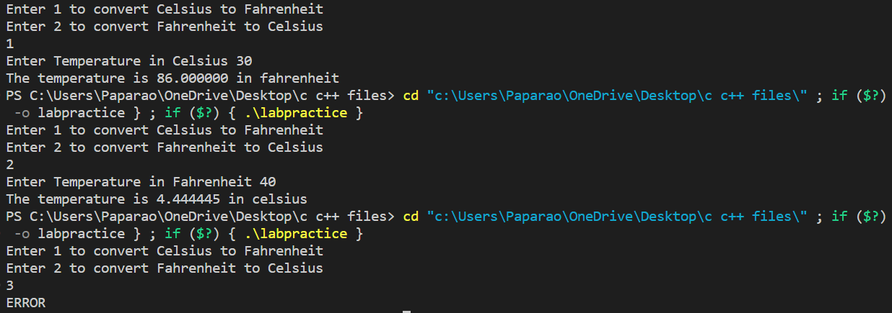

**10. (a) Write a C program to check whether a character is an alphabet, digit.**

**CODE –**

**#include<stdio.h>**

**#include<conio.h>**

**void main()**

**{**

**char c;**

**int b;**

**printf("Please enter a character ");**

**scanf("%c", &c);**

**printf("The ASCII number for given character is %d \n", c);**

**b =c;**

**if(b>47 && b<58)**

**{**

**printf("It is an Integer");**

**}**

**else if (b>64 && b<91)**

**{**

**printf("It is a Capital Alphabet");**

**}**

**else if (b>96 && b<123)**

**{**

**printf("It is a Small Alphabet");**

**}**

**else**

**{**

**printf("It is a Special Character");**

**}**

**}**

**OUTPUT –**

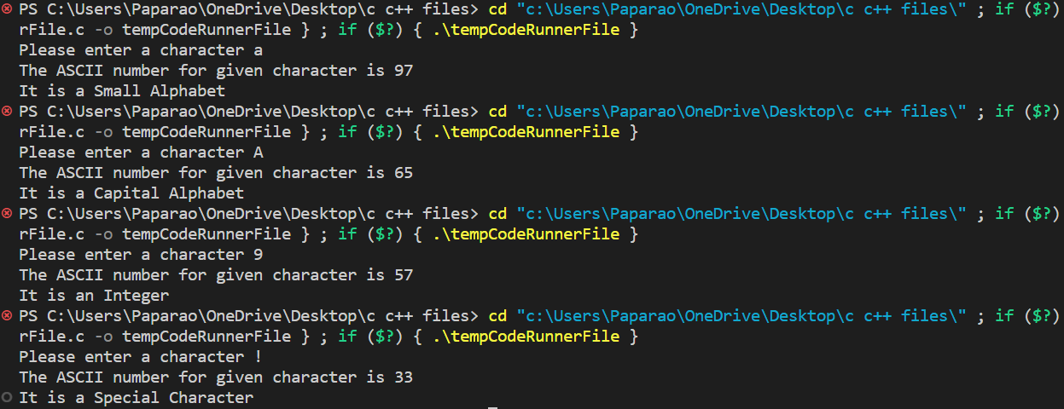

**10.** **(b) Write a C program a program to check whether an alphabet is a vowel or consonant.**

**CODE –**

**#include<stdio.h>**

**#include<conio.h>**

**void main()**

**{**

**char c;**

**int b;**

**printf("Please enter an alphabet ");**

**scanf("%c", &c);**

**printf("The ASCII number for given character is %d \n", c);**

**b =c;**

**if(b==65 || b==69 || b==73 || b==79 || b==85 || b==97 || b==101 || b ==105 || b==111 || b==117)**

**{**

**printf("It is a Vowel");**

**}**

**else**

**{**

**printf("It is a Consonant");**

**}**

**}**

**OUTPUT-**

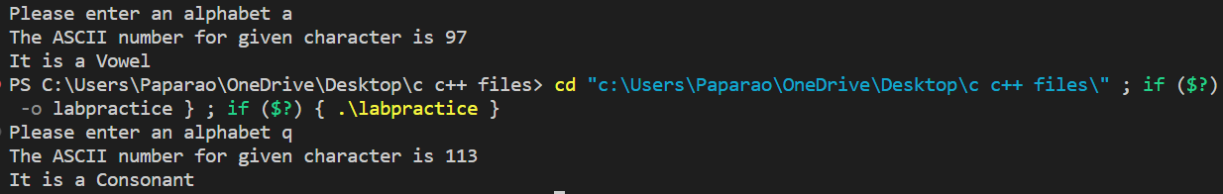

**11. (a) Write a C program to find smallest of two numbers.**

**CODE –**

**#include<stdio.h>**

**#include<conio.h>**

**void main()**

**{**

**int a,b;**

**printf("Enter First Number ");**

**scanf("%d",&a);**

**printf("Enter Second Number ");**

**scanf("%d",&b);**

**if(a>b)**

**{**

**printf("The First Number is greater than Second");**

**}**

**else if (a<b)**

**{**

**printf("The Second Number is greater than First");**

**}**

**else if (a==b)**

**{**

**printf("Both the numbers are equal");**

**}**

**}**

**OUTPUT-**

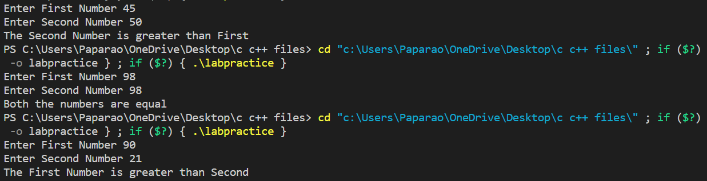

**11.** **(b) Write a C program to find largest of three numbers.**

**CODE –**

**#include<stdio.h>**

**#include<conio.h>**

**void main()**

**{**

**int a,b,c;**

**printf("Enter First Number ");**

**scanf("%d",&a);**

**printf("Enter Second Number ");**

**scanf("%d",&b);**

**printf("Enter Third Number ");**

**scanf("%d",&c);**

**if(a>b && a>c)**

**{**

**printf("The Largest Number is %d",a);**

**}**

**else if (b>a && b>c)**

**{**

**printf("The Largest Number is %d",b);**

**}**

**else if (c>a && c>b)**

**{**

**printf("The Largest Number is %d",c);**

**}**

**else if (a==b && b==c)**

**{**

**printf("All the numbers are equal.");**

**}**

**}**

**OUTPUT-**

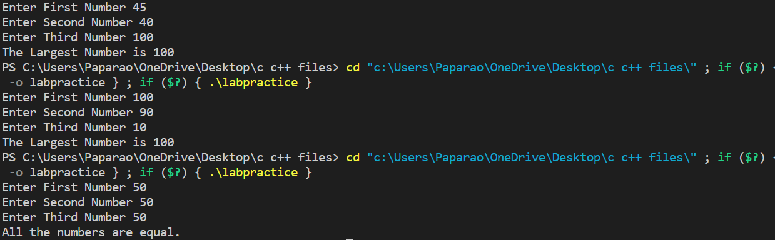

**12. Write a program in C to implement Simple Calculator.**

**CODE –**

**#include<stdio.h>**

**#include<conio.h>**

**void main()**

**{**

**int temp, a, b, c;**

**printf("1. ADDITION\n");**

**printf("2. SUBTRATCTION\n");**

**printf("3. MULTTIPLICATION\n");**

**printf("4. DIVISION\n");**

**printf("Enter corresponding digit for operation\n");**

**scanf("%d",&temp);**

**switch (temp)**

**{**

**case 1:**

**printf("Enter first number ");**

**scanf("%d",&a);**

**printf("Enter second number ");**

**scanf("%d",&b);**

**c = a + b;**

**printf("The sum of the numbers is %d",c);**

**break;**

**case 2:**

**printf("Enter first number ");**

**scanf("%d",&a);**

**printf("Enter second number ");**

**scanf("%d",&b);**

**c = a - b;**

**printf("The difference of the numbers is %d",c);**

**break;**

**case 3:**

**printf("Enter first number ");**

**scanf("%d",&a);**

**printf("Enter second number ");**

**scanf("%d",&b);**

**c = a * b;**

**printf("The product of the numbers is %d",c);**

**break;**

**case 4:**

**printf("Enter first number ");**

**scanf("%d",&a);**

**printf("Enter second number ");**

**scanf("%d",&b);**

**c = a / b;**

**printf("The quotient of the numbers is %d",c);**

**break;**

**default:**

**printf("ERROR");**

**break;**

**}**

**}**

**OUTPUT-**

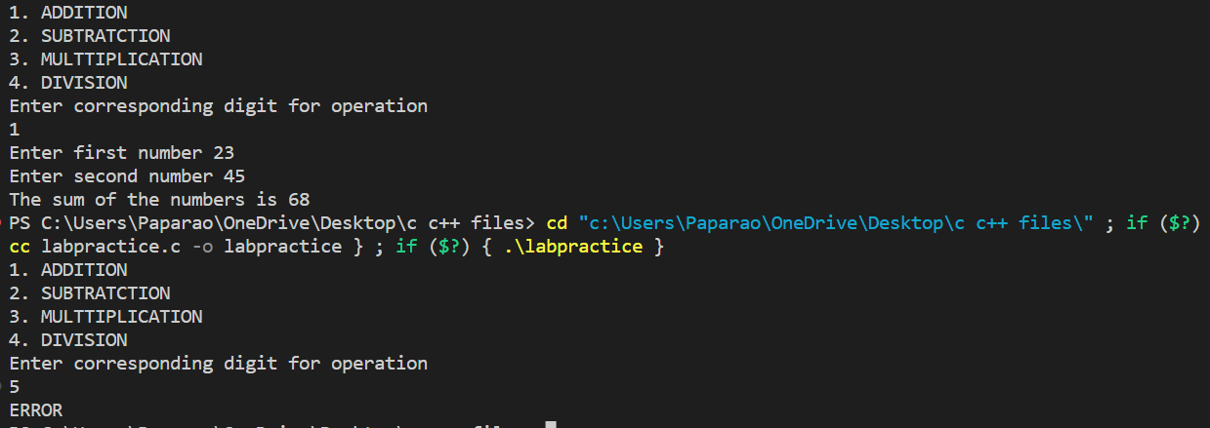

**13. WAP to calculate the root of a Quadratic Equation.**

**CODE –**

**#include<stdio.h>**

**#include<conio.h>**

**#include<math.h>**

**void main()**

**{**

**float a, b, c, root1,root2,d;**

**printf("ax^2 + bx + c =0\n");**

**printf("Enter values of a,b,c respectively");**

**scanf("%f%f%f", &a, &b, &c);**

**d = b*b - 4*(a*c);**

**root1 = -b + sqrt(d);**

**root1 = root1/(2*a);**

**root2 = -b - sqrt(d);**

**root2 = root2/(2*a);**

**printf("The roots are %f and %f.", root1, root2);**

**}**

**OUTPUT –**

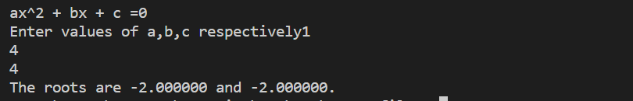

**14. WAP to accept a coordinate point in a XY coordinate system and determine in which quadrant the coordinate point lies.**

**CODE –**

**#include<stdio.h>**

**#include<conio.h>**

**void main()**

**{**

**float x, y;**

**printf("Enter x co-ordinate of point: ");**

**scanf("%f",&x);**

**printf("Enter y co-ordinate of point: ");**

**scanf("%f",&y);**

**if(x>0 && y>0)**

**{**

**printf("The point lies in the first quadrant");**

**}**

**else if(x<0 && y>0)**

**{**

**printf("The point lies in the second quadrant");**

**}**

**else if(x>0 && y<0)**

**{**

**printf("The point lies in the fourth quadrant");**

**}**

**else if(x<0 && y<0)**

**{**

**printf("The point lies in the third quadrant");**

**}**

**else if(x==0 && y==0)**

**{**

**printf("The point lies is origin");**

**}**

**else**

**{**

**printf("The point does not exist");**

**}**

**}**

**OUTPUT –**

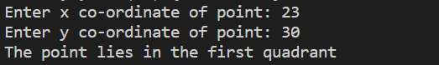

**15. Write a program to find gross salary of employee if DA is 40% of basic Salary and HRA is 20% of basic salary. Basic salary will be entered as input by keyboard.**

**CODE –**

**#include<stdio.h>**

**#include<conio.h>**

**void main()**

**{**

**float basic, gross;**

**printf("Enter basic salary: ");**

**scanf("%f", &basic);**

**gross = basic + 0.4*basic + 0.2*basic;**

**printf("Gross Salary is: %f", gross);**

**}**

**OUTPUT –**



**16. Write a program in C to calculate and print the Electricity bill of a given customer. The customer id and unit consumed by the user should be taken from the keyboard and display the total amount to pay to the customer.**

**upto 199------------1.20**

**200-500-------------1.80**

**Above 500----------2.00**

**If bill exceeds Rs. 400 then a surcharge of 15% will be charged and the minimum bill should be of Rs. 100/-.**

**CODE –**

**#include<stdio.h>**

**void main()**

**{**

**int customerid, units;**

**float bill;**

**printf("Enter customer ID: ");**

**scanf("%d", &customerid);**

**printf("Enter number of units used");**

**scanf("%d",&units);**

**if(units<200)**

**{ bill = 1.20*units; }**

**else if (units<501)**

**{ bill = 1.80*units; }**

**else if (units>500)**

**{ bill = 2.00*units; }**

**if(bill>100)**

**{**

**if(bill>400)**

**{**

**bill = bill + 0.15*bill;**

**printf("The total amount is Rs %f for customer ID %d.",bill,customerid);**

**}**

**else**

**{ printf("The total amount is Rs %f for customer ID %d.",bill,customerid); }**

**}**

**else**

**{**

**printf("bill is lesss than Rs.100");**

**}**

**}**

**OUTPUT –**

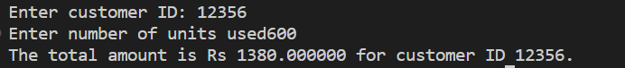

**17. A library charges a fine for every book returned late. For first 5 days the fine is 50 paisa, for 6-10 days, fine is one rupee and above 10 days, fine is 5 rupees. If you return the book after 30 days your membership will be cancelled. Write a program to accept the number of days the member is late to return the book and display the fine or appropriate message.**

**CODE –**

**#include<stdio.h>**

**#include<conio.h>**

**void main()**

**{**

**int days, fine;**

**printf("Enter number of days late: ");**

**scanf("%d",&days);**

**if(days<6)**

**{ fine = 0.5*days;**

**printf("The fine is Rs.%d",fine);**

**}**

**else if (days<11)**

**{fine = days;**

**printf("The fine is Rs.%d",fine);**

**}**

**else if (days>10 && days<31)**

**{fine = 5*days;**

**printf("The fine is Rs.%d",fine);**

**}**

**else if (days>30)**

**{ printf("Your membership has been terminated");**

**}**

**}**

**OUTPUT –**

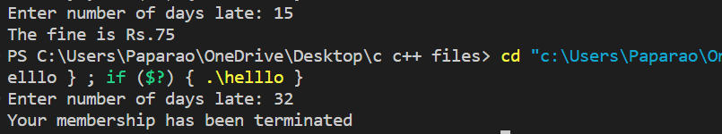

**18. Write a program to find the factorial of any number.**

**CODE –**

**#include<stdio.h>**

**#include<conio.h>**

**void main()**

**{**

**int numb,fact,i;**

**fact = 1;**

**printf("Enter the number: ");**

**scanf("%d", &numb);**

**for (i = numb; i>0; i--)**

**{**

**fact = fact*i;**

**}**

**printf("The factorial is %d",fact);**

**}**

**OUTPUT –**

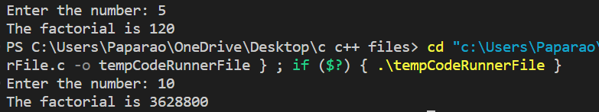

**19. Write a program to print Fibonacci sequence 0 1 1 2 3 5 8 13…… N terms and print the sum of sequence.**

**CODE –**

**#include<stdio.h>**

**#include<conio.h>**

**void main()**

**{**

**int n1, n2, n3, sum, n;**

**sum = 1;**

**n1 = 0;**

**n2 = 1;**

**n3 = 0;**

**printf("Enter number of terms required: ");**

**scanf("%d", &n);**

**printf("The Fibonacci series is: %d\t%d\t",n1,n2);**

**for(int i = 2; i<n; i++)**

**{**

**n3 = n1 + n2;**

**printf("%d\t",n3);**

**sum = sum + n3;**

**n1 = n2;**

**n2 = n3;**

**}**

**printf("\nThe sum of the series is: %d",sum);**

**}**

**OUTPUT –**



**20. Write a program in C to accept an integer number and find sum of digits.**

**CODE –**

**#include<stdio.h>**

**#include<conio.h>**

**void main()**

**{**

**int numb, sum, t, rem;**

**printf("Enter Number: ");**

**scanf("%d", &numb);**

**t = numb;**

**sum =0;**

**while (t!= 0)**

**{**

**rem = t%10;**

**sum = sum + rem;**

**t /= 10;**

**}**

**printf("sum of digits of the number is: %d",sum);**

**}**

**OUTPUT –**



**21. Write a program in C to accept an integer numbers and find reverse of this number and check this number for palindrome.**

**CODE –**

**#include<stdio.h>**

**#include<conio.h>**

**void main()**

**{**

**int numb, palin = 0,temp, rem;**

**printf("Enter a number: ");**

**scanf("%d",&numb);**

**temp = numb;**

**while (numb > 0)**

**{**

**rem = numb % 10;**

**palin = palin*10 + rem;**

**numb /= 10;**

**}**

**printf("Given  Number is: %d", temp);**

**printf("\nThe reverse of the given number is: %d",palin);**

**if(palin == temp)**

**{**

**printf("\nThe given number is a palindrome");**

**}**

**else**

**{**

**printf("\nThe given number is not a palindrome");**

**}**

**}**

**OUTPUT –**

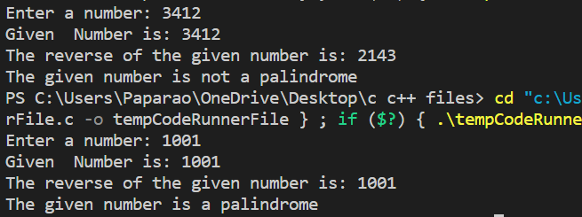

**22. Write a program in C to accept an integer number and to check a number is Armstrong or not.**

**CODE –**

**#include<stdio.h>**

**#include<conio.h>**

**void main()**

**{**

**int numb, temp, rem = 0, result = 0;**

**printf("Enter a three digit number: ");**

**scanf("%d",&numb);**

**temp = numb;**

**while(numb!=0)**

**{**

**rem = numb % 10;**

**result += rem * rem *rem;**

**numb /= 10;**

**}**

**if(result == temp)**

**{**

**printf("The given number is an Armstrong number");**

**}**

**else**

**{**

**printf("The given number is not an Armstrong number");**

**}**

**}**

**OUTPUT –**





**23. Write a program in C to accept an integer number and to check a number is Perfect or not.**

**CODE –**

**#include<stdio.h>**

**#include<conio.h>**

**void main()**

**{**

**int numb, i, sum;**

**printf("Enter any number: ");**

**scanf("%d",&numb);**

**for(i=1; i<=numb/2; i++)**

**{**

**if(numb%i == 0)**

**{**

**sum += i;**

**}**

**}**

**if (numb == sum)**

**{**

**printf("The given number is perfect");**

**}**

**else**

**{**

**printf("The given number is not perfect");**

**}**

**}**

**OUTPUT –**





**24. Write a program to find the sum of following series: S = 2+4+6+8+……………N terms.**

**CODE –**

**#include<stdio.h>**

**#include<conio.h>**

**void main()**

**{**

**int numb, i, sum;**

**printf("Enter number of terms required: ");**

**scanf("%d",&numb);**

**for(i=2; i<=numb; i+=2)**

**{**

**sum = sum+i;**

**}**

**printf("The sum of the series is: %d",sum);**

**}**

**OUTPUT –**





**25. Write a program to check a number whether it is prime number or not.**

**CODE –**

**#include<stdio.h>**

**#include<conio.h>**

**void main()**

**{**

**int numb, i, prime=0;**

**printf("Enter any number: ");**

**scanf("%d",&numb);**

**for(i=2; i<numb; i++)**

**{**

**if(numb%i==0)**

**{**

**prime = 1;**

**break;**

**}**

**}**

**if(prime == 0)**

**{**

**printf("The number is prime");**

**}**

**else if (prime == 1)**

**{**

**printf("The number is not prime");**

**}**

**}**

**OUTPUT –**





**26. Write a program to find the sum of following series: 1 – 1/2 + 1/3 – 1/4 + 1/5 - …… up to n terms.**

**CODE –**

**#include<stdio.h>**

**#include<conio.h>**

**void main()**

**{**

**int numb, i;**

**float sum = 0, j;**

**printf("Enter number of terms required: ");**

**scanf("%d",&numb);**

**for(i=1; i<=numb; i++)**

**{**

**if(i%2 == 0)**

**{**

**j = -1;**

**}**

**else if (i%2 == 1)**

**{**

**j = 1;**

**}**

**j /= i;**

**sum = sum + j;**

**}**

**printf("The sum of the series is: %f",sum);**

**}**

**OUTPUT –**



**27. Write a program to find the sum of following series: 1! + 2! + 3! + 4! + ….. + n!**

**CODE –**

**#include<stdio.h>**

**#include<conio.h>**

**void main()**

**{**

**int numb, i, sum=0,fact,j;**

**printf("Enter number of terms required: ");**

**scanf("%d",&numb);**

**for(i=1; i<=numb; i++)**

**{**

**fact=1;**

**for(j=i; j>0; j--)**

**{**

**fact = fact*j;**

**}**

**sum = sum+fact;**

**}**

**printf("The sum of the series is: %d",sum);**

**}**

**OUTPUT –**



**28. Write a program to find the sum of following series: S = -1^3 + 3^3 – 5^3 + 7^3 – 9^3 + 11^3 - ……..N terms.**

**CODE –**

**#include<stdio.h>**

**#include<conio.h>**

**void main()**

**{**

**int i, numb, fact, j=0, sum=0,k;**

**printf("Enter number of terms required: ");**

**scanf("%d",&numb);**

**for(i=1,k=1;i<=numb;i++, k+=2)**

**{**

**if(i%2==0)**

**{**

**j=1;**

**}**

**else if (i%2==1)**

**{**

**j=-1;**

**}**

**fact = j*(k*k*k);**

**sum = sum + fact;**

**}**

**printf("Sum of the terms is: %d",sum);**

**}**

**OUTPUT –**



**29. Write a program to find the sum of following series: S = 1/1! + 2/2! + 3/3! + ………….. 7 terms.**

**CODE –**

**#include<stdio.h>**

**#include<conio.h>**

**void main()**

**{**

**int i,k;**

**float fact,sum =0;**

**for(i=1;i<=7;i++)**

**{**

**fact =1;**

**for(k=i; k>0; k--)**

**{**

**fact *= k;**

**}**

**sum = sum + i/fact;**

**}**

**printf("Sum of the terms is: %f",sum);**

**}**

**OUTPUT –**



**30. Write a program to convert binary number to decimal number.**

**CODE –**

**#include<stdio.h>**

**#include<math.h>**

**void main()**

**{**

**int numb, bin, i, deci =0;**

**printf("Enter any binary number: ");**

**scanf("%d",&numb);**

**for(i=0;numb>0;++i)**

**{**

**bin = numb%10;**

**deci += bin*pow(2,i);**

**numb /= 10;**

**}**

**printf("The decimal equivalent is: %d",deci);**

**}**

**OUTPUT –**



**31. Write a program to find the sum of following series: S = 1^4 + 3^4 + 5^4 + 7^4 + …………….. 100 terms.**

**CODE –**

**#include<stdio.h>**

**#include<math.h>**

**void main()**

**{**

**int numb =1;**

**unsigned long int sum =0;**

**for(int i =1; i<=100; i++)**

**{**

**sum += pow(numb,4);**

**numb += 2;**

**}**

**printf("The sum of the seires is: %d", sum);**

**}**

**OUTPUT –**



**32. Write a program in C to print the following pattern:**

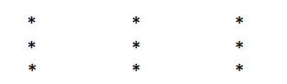

**CODE –**

**#include<stdio.h>**

**#include<math.h>**

**void main()**

**{**

**for(int i=1; i <=3; i++)**

**{**

**for(int j =1; j<=3; j++)**

**{**

**printf("*\t");**

**}**

**printf("\n");**

**}**

**}**

**OUTPUT –**



**33. Write a program in C to print the following pattern:**

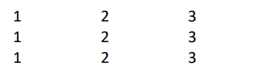

**CODE –**

**#include<stdio.h>**

**#include<math.h>**

**void main()**

**{**

**for(int i=1; i <=3; i++)**

**{**

**for(int j =1; j<=3; j++)**

**{**

**printf("%d\t",j);**

**}**

**printf("\n");**

**}**

**}**

**OUTPUT –**

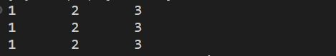

**34. Write a program in C to print the following pattern:**

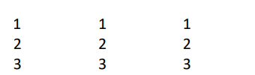

**CODE –**

**#include<stdio.h>**

**#include<math.h>**

**void main()**

**{**

**for(int i=1; i <=3; i++)**

**{**

**for(int j =1; j<=3; j++)**

**{**

**printf("%d\t",i);**

**}**

**printf("\n");**

**}**

**}**

**OUTPUT –**

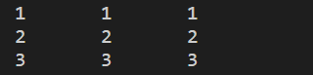

**35. Write a program in C to print the following pattern:**

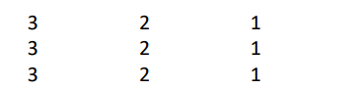

**CODE –**

**#include<stdio.h>**

**#include<math.h>**

**void main()**

**{**

**for(int i=1; i <=3; i++)**

**{**

**for(int j =3; j>0; j--)**

**{**

**printf("%d\t",j);**

**}**

**printf("\n");**

**}**

**}**

**OUTPUT –**

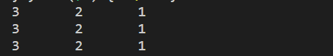

**36. Write a program in C to print the following pattern:**

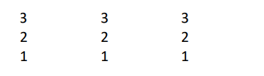

**CODE –**

**#include<stdio.h>**

**#include<math.h>**

**void main()**

**{**

**for(int i=3; i >0; i--)**

**{**

**for(int j =3; j>0; j--)**

**{**

**printf("%d\t",i);**

**}**

**printf("\n");**

**}**

**}**

**OUPUT –**

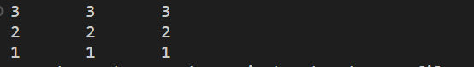

**37. Write a program in C to print the following pattern:**

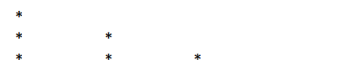

**CODE –**

**#include<stdio.h>**

**#include<math.h>**

**void main()**

**{**

**for(int i=1; i <= 3; i++)**

**{**

**for(int j =0; j<i; j++)**

**{**

**printf("*\t");**

**}**

**printf("\n");**

**}**

**}**

**OUTPUT –**



**38. Write a program in C to print the following pattern:**

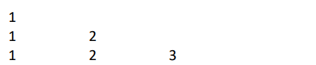

**CODE –**

**#include<stdio.h>**

**#include<math.h>**

**void main()**

**{**

**for(int i=1; i <= 3; i++)**

**{**

**for(int j =1; j<=i; j++)**

**{**

**printf("%d\t",j);**

**}**

**printf("\n");**

**}**

**}**

**OUTPUT –**

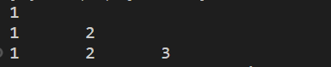

**39. Write a program in C to print the following pattern:**

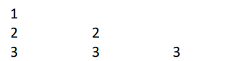

**CODE –**

**#include<stdio.h>**

**#include<math.h>**

**void main()**

**{**

**for(int i=1; i <= 3; i++)**

**{**

**for(int j =1; j<=i; j++)**

**{**

**printf("%d\t",i);**

**}**

**printf("\n");**

**}**

**}**

**OUTPUT –**

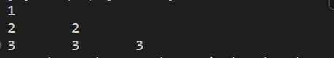

**40. Write a program in C to print the following pattern:**

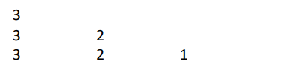

**CODE –**

**#include<stdio.h>**

**#include<math.h>**

**void main()**

**{**

**for(int i=3; i >0; i--)**

**{**

**for(int j =3; j>=i; j--)**

**{**

**printf("%d\t",j);**

**}**

**printf("\n");**

**}**

**}**

**OUTPUT –**

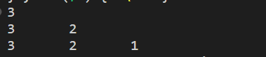

**41. Write a program in C to print the following pattern:**

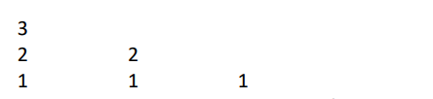

**CODE –**

**#include<stdio.h>**

**#include<math.h>**

**void main()**

**{**

**for(int i=3; i >0; i--)**

**{**

**for(int j =3; j>=i; j--)**

**{**

**printf("%d\t",i);**

**}**

**printf("\n");**

**}**

**}**

**OUTPUT –**

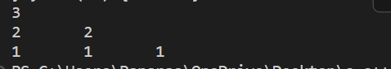

**42. Write a program in C to print the following pattern:**

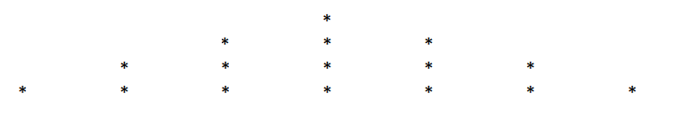

**CODE –**

**#include<stdio.h>**

**#include<math.h>**

**void main()**

**{**

**int space = 0, k;**

**for(int i=1; i <= 4; i++)**

**{**

**for(int j = 3; j>=i; j--)**

**{**

**printf("\t");**

**}**

**for(k=0;k != 2*i - 1;k++)**

**{**

**printf("*\t");**

**}**

**printf("\n");**

**}**

**}**

**OUTPUT –**



**43. Write a program in C to print the following pattern:**

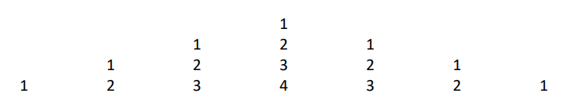

**CODE –**

**#include<stdio.h>**

**void main()**

**{**

**int i, j, k, n=4;**

**for(i=1; i<=n; i++)**

**{**

**for (j =1; j<=n-i; j++)**

**{**

**printf("\t");**

**}**

**for(j=1; j<=i; j++)**

**{**

**printf("%d\t",j);**

**}**

**for(j=i-1; j>0; j--)**

**{**

**printf("%d\t", j);**

**}**

**printf("\n");**

**}**

**}**

**OUTPUT –**

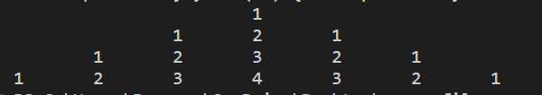

**44. Write a program in C to print the following pattern:**

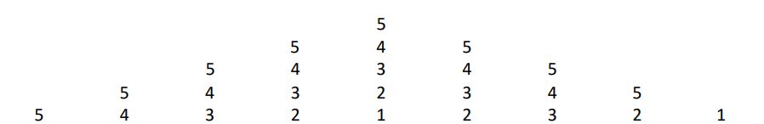

**CODE –**

**#include<stdio.h>**

**void main()**

**{**

**int i, j, k, n=1;**

**for(i=5; i>=n; i--)**

**{**

**for (j =1; j<=i-n; j++)**

**{**

**printf("\t");**

**}**

**for(j=5; j>=i; j--)**

**{**

**printf("%d\t",j);**

**}**

**for(j=i+1; j<=5; j++)**

**{**

**printf("%d\t", j);**

**}**

**printf("\n");**

**}**

**}**

**OUTPUT –**

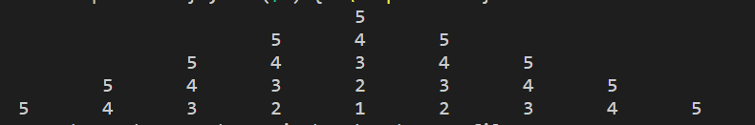

**45. Write a program in C to print the following pattern:**

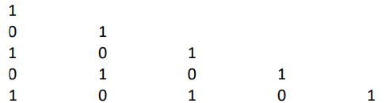

**CODE –**

**#include<stdio.h>**

**void main()**

**{**

**int i, j, count = 1;**

**for(i=0; i<5; i++)**

**{**

**for (j = 0; j<=i; j++)**

**{**

**printf("%d\t", count);**

**count = !count;**

**}**

**count = i % 2;**

**printf("\n");**

**}**

**}**

**OUTPUT –**

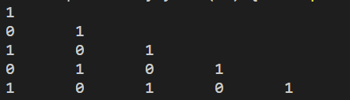

**46. Write a program to print all prime numbers <= a given number.**

**CODE –**

**#include<stdio.h>**

**void main()**

**{**

**int n, count, prime;**

**printf("Enter last number: ");**

**scanf("%d", &n);**

**for(int i = 1; i<=n; i++)**

**{**

**count =0;**

**for (int j = 1; j <= i; j++)**

**{**

**if(i % j ==0)**

**{**

**count++;**

**}**

**}**

**if (count == 2 )**

**{**

**printf("%d\t", i);**

**}**

**}**

**}**

**OUTPUT –**



**47. Write a program to convert Decimal no to Binary No.**

**CODE –**

**#include<stdio.h>**

**#include<conio.h>**

**void main()**

**{**

**int numb, rem, temp;**

**printf("Enter the number in DECIMAL form: ");**

**scanf("%d",&numb);**

**temp = numb;**

**printf("Binary of given number is: ");**

**for(int i =0; numb>0; i++)**

**{**

**rem = 0;**

**rem = numb%2;**

**numb /= 2;**

**printf("%d",rem);**

**}**

**}**

**OUTPUT –**



**48. Write a program to find product, sum, average, max and min from a list of n numbers.**

**CODE –**

**#include<stdio.h>**

**#include<conio.h>**

**void main()**

**{**

**int arr[100], product = 1, sum =0, max, min, avg, n;**

**printf("Enter number of elements in the array: ");**

**scanf("%d", &n);**

**printf("Enter elements:\n");**

**for(int i =0; i<n; i++)**

**{**

**scanf("%d", &arr[i]);**

**}**

**max = arr[0];**

**min = arr[0];**

**for (int i = 0; i < n; i++)**

**{**

**sum = sum + arr[i];**

**product = product * arr[i];**

**if(arr[i] > max)**

**{**

**max = arr[i];**

**}**

**if(arr[i] < min)**

**{**

**min = arr[i]}**

**}**

**avg = sum / n;**

**printf("The sum, product, average, max, min are %d %d %d %d %d rspectively.",sum, product, avg, max, min);**

**}**

**OUTPUT –**

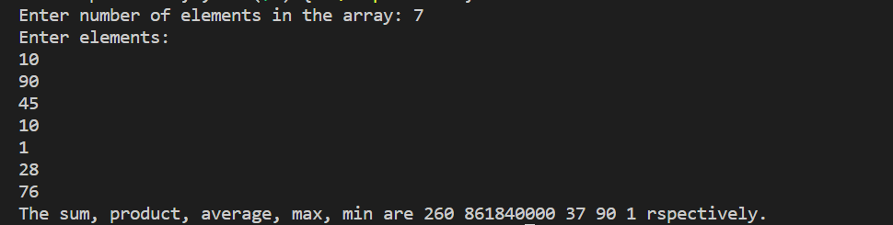

**49. Write a program in C to display the index of smallest and largest element in 10 integers.**

**CODE –**

**#include<stdio.h>**

**#include<conio.h>**

**void main()**

**{**

**int arr[10],max, min, maxin, minin;**

**printf("Enter elements:\n");**

**for(int i =0; i<10; i++)**

**{ scanf("%d", &arr[i])}**

**max = arr[0];**

**min = arr[0];**

**for (int i = 0; i < 10; i++)**

**{**

**if(arr[i] > max)**

**{**

**max = arr[i];**

**maxin = i +1;**

**}**

**if(arr[i] < min)**

**{**

**min = arr[i];**

**minin = i +1;**

**}**

**}**

**printf("The index of largest number is %d\n", maxin);**

**printf("The index of smallest number is %d", minin);**

**}**

**OUTPUT –**

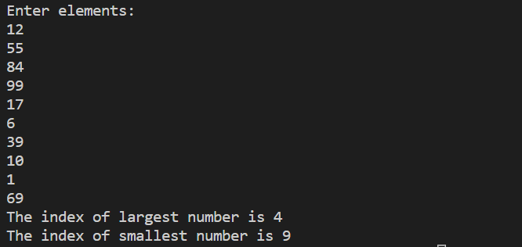

**50. Write a program in C to display the index of smallest and largest element in 3 X 4 matrix of integers.**

**CODE –**

**#include<stdio.h>**

**void main()**

**{**

**int arr[3][4],max, min, maxrow, minrow, maxcol, mincol;**

**printf("Enter elements:\n");**

**for(int i =0; i<3; i++)**

**{**

**for(int j =0; j<4; j++)**

**{**

**scanf("%d", &arr[i][j]);**

**}**

**}**

**max = arr[0][0];**

**min = arr[0][0];**

**for (int i = 0; i < 3; i++)**

**{**

**for(int j =0; j<4; j++)**

**{**

**if(arr[i][j] > max)**

**{**

**max = arr[i][j];**

**maxrow = i +1;**

**maxcol = j+1;**

**}**

**if(arr[i][j] < min)**

**{**

**min = arr[i][j];**

**minrow = i +1;**

**mincol = j +1;**

**}**

**}**

**}**

**printf("The index of largest number is (%d,%d)\n", maxrow, maxcol);**

**printf("The index of smallest number is (%d,%d)", minrow, mincol);**

**}**

**OUTPUT –**

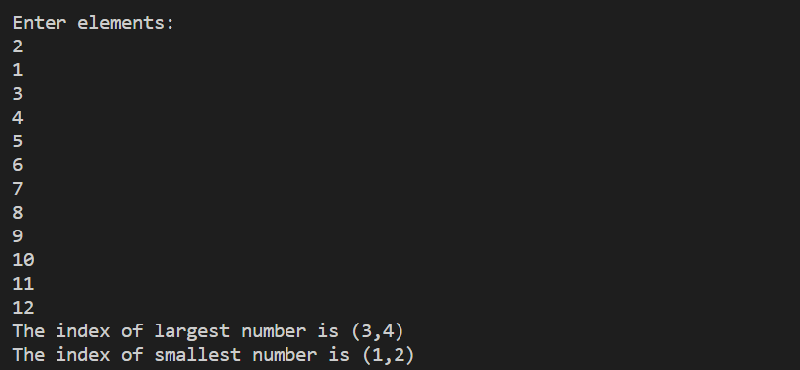

**51. Write a program in C that accepts N*N matrix as input and print transpose of this matrix.**

**CODE –**

**#include<stdio.h>**

**void main()**

**{**

**int arr[100][100], transpose[100][100], order;**

**printf("Enter Order of matrix: ");**

**scanf("%d", &order);**

**printf("Enter elements:\n");**

**for(int i = 0; i< order; i++)**

**{**

**for(int j =0; j<order; j++)**

**{**

**scanf("%d", &arr[i][j]);**

**}**

**}**

**for(int i = 0; i< order; i++)**

**{**

**for(int j =0; j<order; j++)**

**{**

**transpose[i][j] = arr[j][i];**

**}**

**}**

**for(int i = 0; i< order; i++)**

**{**

**for(int j =0; j<order; j++)**

**{**

**printf("%d\t", transpose[i][j]);**

**}**

**printf("\n");**

**}}**

**OUTPUT -**

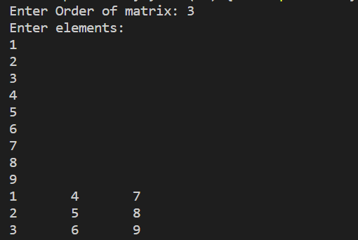 

**52. Write a program to accept two matrices of same order. (Order must be given by user) find out the sum of these matrices and print the sum of matrices.**

**CODE –**

**#include<stdio.h>**

**void main()**

**{**

**int arr1[100][100], arr2[100][100],sum[100][100], order;**

**printf("Enter Order of matrix: ");**

**scanf("%d", &order);**

**printf("Enter elements of first matrix:\n");**

**for(int i = 0; i< order; i++)**

**{**

**for(int j =0; j<order; j++)**

**{**

**scanf("%d", &arr1[i][j]);**

**}**

**}**

**printf("Enter elements of second matrix:\n");**

**for(int i = 0; i< order; i++)**

**{**

**for(int j =0; j<order; j++)**

**{**

**scanf("%d", &arr2[i][j]);**

**}**

**}**

**for(int i = 0; i< order; i++)**

**{**

**for(int j =0; j<order; j++)**

**{**

**sum[i][j] = arr1[i][j] + arr2[i][j];**

**}**

**}**

**printf("The sum of the matrices are:\n");**

**for(int i = 0; i< order; i++)**

**{**

**for(int j =0; j<order; j++)**

**{**

**printf("%d\t", sum[i][j]);**

**}**

**printf("\n");**

**}**

**}**

**OUTPUT –**

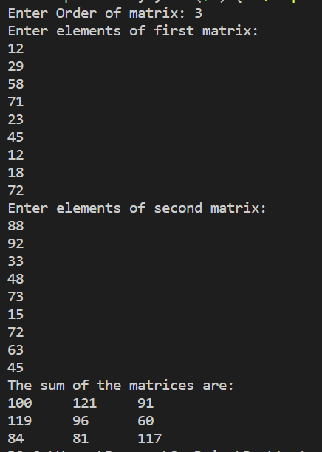

**53. Write a program to find out the product/Multiplication of two matrices and print the product matrix. (Order of matrices must be given by user).**

**CODE –**

**#include<stdio.h>**

**void main()**

**{**

**int arr1[100][100], arr2[100][100],prod[100][100], order;**

**printf("Enter Order of matrix: ");**

**scanf("%d", &order);**

**printf("Enter elements of first matrix:\n");**

**for(int i = 0; i< order; i++)**

**{**

**for(int j =0; j<order; j++)**

**{**

**scanf("%d", &arr1[i][j]);**

**}**

**}**

**printf("Enter elements of second matrix:\n");**

**for(int i = 0; i< order; i++)**

**{**

**for(int j =0; j<order; j++)**

**{**

**scanf("%d", &arr2[i][j]);**

**}**

**}**

**for (int i =0; i<order; i++)**

**{**

**for(int j =0; j< order; j++)**

**{**

**prod[i][j] = 0;**

**for(int k = 0; k<order; k++)**

**{**

**prod[i][j] += arr1[i][k] * arr2[k][j];**

**}**

**printf("%d\t", prod[i][j]);**

**}**

**printf("\n");**

**}**

**}**

**OUTPUT –**

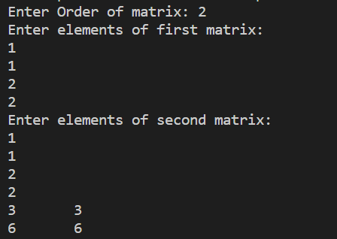

**54. Write a program to accept two matrices of some order. (Order must be given by user) find out the subtraction of these matrices and print the sum of matrices.**

**CODE –**

#include<stdio.h>

void main()

{

    int arr1[100][100], arr2[100][100], sum[100][100], order, sub1[100][100], sub2[100][100];

    printf("Enter Order of matrix: ");

    scanf("%d", &order);

    printf("Enter elements of first matrix:\n");

    for(int i = 0; i< order; i++)

    {

        for(int j =0; j<order; j++)

        {

            scanf("%d", &arr1[i][j]);

        }

    }

    printf("Enter elements of second matrix:\n");

    for(int i = 0; i< order; i++)

    {

        for(int j =0; j<order; j++)

        {

            scanf("%d", &arr2[i][j]);

        }

    }

    for(int i = 0; i< order; i++)

    {

        for(int j =0; j<order; j++)

        {

            sum[i][j] = arr1[i][j] + arr2[i][j];

        }

    }

    for(int i = 0; i< order; i++)

    {

        for(int j =0; j<order; j++)

        {

            sub1[i][j] = arr1[i][j] - arr2[i][j];

        }

    }

    for(int i = 0; i< order; i++)

    {

        for(int j =0; j<order; j++)

        {

            sub2[i][j] = arr2[i][j] - arr1[i][j];

        }

    }

    printf("The sum of the matrices are:\n");

    for(int i = 0; i< order; i++)

    {

        for(int j =0; j<order; j++)

        {

            printf("%d\t", sum[i][j]);

        }

        printf("\n");

    }

    printf("The difference of the matrices (A-B) is:\n");

    for(int i = 0; i< order; i++)

    {

        for(int j =0; j<order; j++)

        {

            printf("%d\t", sub1[i][j]);

        }

        printf("\n");

    }

    printf("The difference of the matrices(B-A) is:\n");

    for(int i = 0; i< order; i++)

    {

        for(int j =0; j<order; j++)

        {

            printf("%d\t", sub2[i][j]);

        }

        printf("\n");

    }

}

**OUTPUT –**

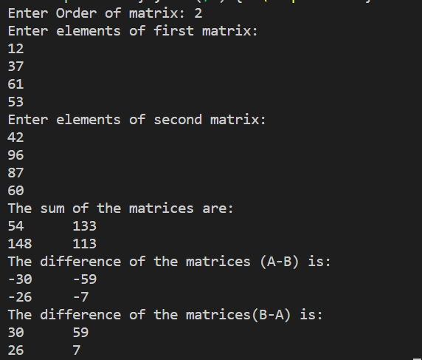

**55. Write a C Program to implement Simple Calculator (Addition, Subtraction, Multiplication, Division) using the concept of function.**

**CODE –**

**#include<stdio.h>**

**int sum(int a, int b)**

**{**

**return a+b;**

**}**

**int diff(int a, int b)**

**{**

**return a-b;**

**}**

**int prod(int a, int b)**

**{**

**return a*b;**

**}**

**int div(int a, int b)**

**{**

**return a/b;**

**}**

**void main()**

**{**

**int num1, num2, n;**

**printf("1. ADDITION\n2. SUBTRACTION\n3. MULTIPLICATION\n4. DIVISION\n");**

**printf("Enter corresponding number: ");**

**scanf("%d", &n);**

**printf("Enter first number: ");**

**scanf("%d", &num1);**

**printf("Enter second number: ");**

**scanf("%d", &num2);**

**switch (n)**

**{**

**case 1:**

**printf("%d",sum(num1, num2));**

**break;**

**case 2:**

**printf("%d", diff(num1,num2));**

**break;**

**case 3:**

**printf("%d", prod(num1, num2));**

**break;**

**case 4:**

**printf("%d", div(num1, num2));**

**break;**

**default:**

**printf("ERROR");**

**break;**

**}**

**}**

**OUTPUT –**

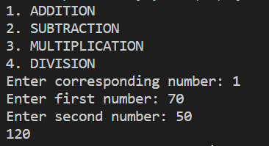

**56. Write a C Program to swap two values using function.**

**CODE –**

**#include<stdio.h>**

**int swap(int num1, int num2)**

**{**

**int temp = num1;**

**num1 = num2;**

**num2 = temp;**

**printf("%d,%d", num1, num2);**

**}**

**void main()**

**{**

**int a, b;**

**printf("Enter first number: ");**

**scanf("%d", &a);**

**printf("Enter second number: ");**

**scanf("%d", &b);**

**swap(a,b);**

**}**

**OUTPUT –**

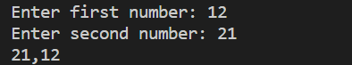

**57. Write a C Program to Calculate the factorial of a number using function.**

**CODE –**

**#include<stdio.h>**

**int factorial(int n)**

**{**

**int fact = 1;**

**for(int i = 1; i<n+1; i++)**

**{**

**fact *= i;**

**}**

**printf("The facotrial of %d is: %d", n, fact);**

**}**

**void main()**

**{**

**int n;**

**printf("Enter number: ");**

**scanf("%d", &n);**

**factorial(n);**

**}**

**OUTPUT –**



**58. Write a C Program to Calculate the factorial of a number using recursion.**

**CODE –**

**#include<stdio.h>**

**int factorial(int n)**

**{**

**if (n == 1)**

**{**

**return 1;**

**}**

**return n * factorial(n-1);**

**}**

**void main()**

**{**

**int n;**

**printf("Enter number: ");**

**scanf("%d", &n);**

**printf("%d",factorial(n));**

**}**

**OUTPUT –**

